**Homework 11 (Group) (Week-17): Cox Model**

Given the remission time data (Z,δ,X1,X2), where X1 is the treatment status (X1 = 1 for treatment, and X1 = 0 for placebo), and X2 is the measurement of WBC. Also deﬁne X*2 = 0 if X2 < median(X2), and X*2 = 1 if X2 ≥ median(X2). Using the Cox PH model to answer the following questions (under the Type-I error α = 0.05).

1. **What are the HR of the treatment status and WBC? Are they risk factors or protective factors to remission time**

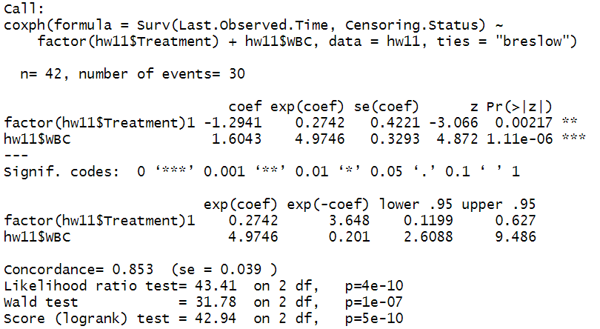

HR of treatment=0.2742

HR of WBC=4.9746

Coefficient of treatment=-1.2941<0 🡪 protective factor to remission time

Coefficient of WBC=1.6043>0 🡪 risk factor to remission time

1. **Will the treatment status and WBC aﬀect remission time?**



h(t|x)=h0(t)*exp(β1X1+β2X2)

h0(t): baseline hazard function

t: remission time

X1: treatment

X2: WBC

β1: 固定其他變項下，treatment=1相對於treatment=0的風險比率為eβ1倍

β2: 固定其他變項下，每增加1單位的WBC，風險比率平均增加eβ2倍

H0: β1=β2=0

H1: β1, β2不均為0

After wald test, p-value=1e-07<α(0.05)，reject H0，β1, β2不均為0，所以treatment和WBC統計顯著地影響remission time。

1. **Will the treatment status aﬀect remission time after controlling WBC?**

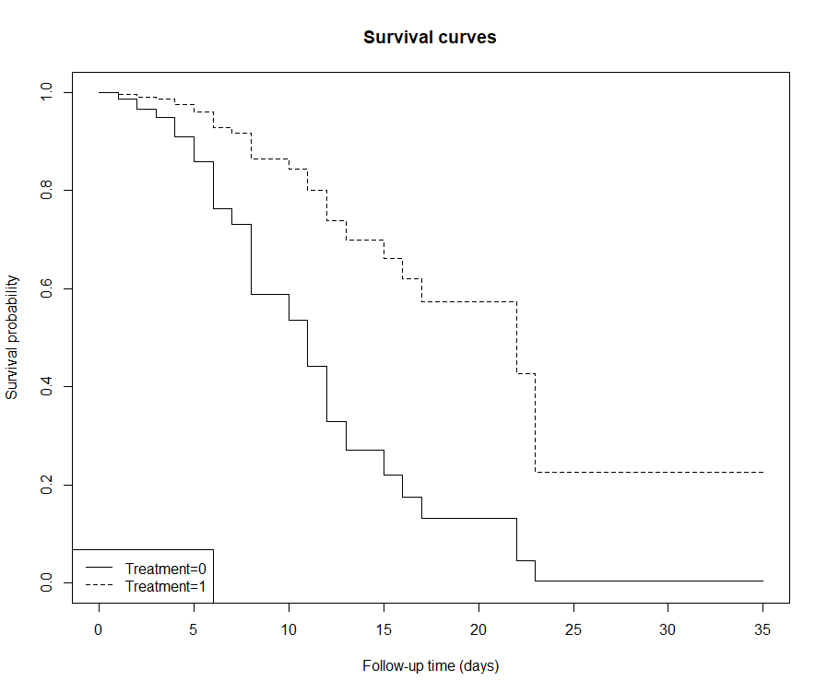

上圖為將WBC控制為median(WBC)=2.8，繪製出兩條treatment分別為0與1的survival curves，可見treatment=1皆不低於treatment=0的圖形，且treatment=1曲線下面積大於treatment=0，因此treatment status aﬀects remission time after controlling WBC。

1. **Comparing the results of (b)-(c) to the same problems in Homework 10, do you gain anything from ﬁtting the Cox PH model?**

Homework10使用的方法為log rank test，將WBC進行離散化後有兩組不同的WBC-status，利用不同類別變項來看其如何影響存活曲線，而Homework11的Cox PH model是直接用WBC的資料去估計Hazard ratio,可透過報表得到 $β1$, $β2$，並判斷其為保護因子或是危險因子，此外，在兩份作業的(c)小題中，由於Homework 10的Treatment及WBC-status各有兩種情況，因而得到四條存活曲線，而Homework11是取WBC的中位數進行控制，因此所得的兩條存活曲線為WBC皆控制在中位數時，不同治療方式的存活曲線。

1. **Plot the estimated survival functions S(t|X1,X2) at X1 ∈ {0,1} and X2 ∈ {Q1,Q3} using Cox PH model.**

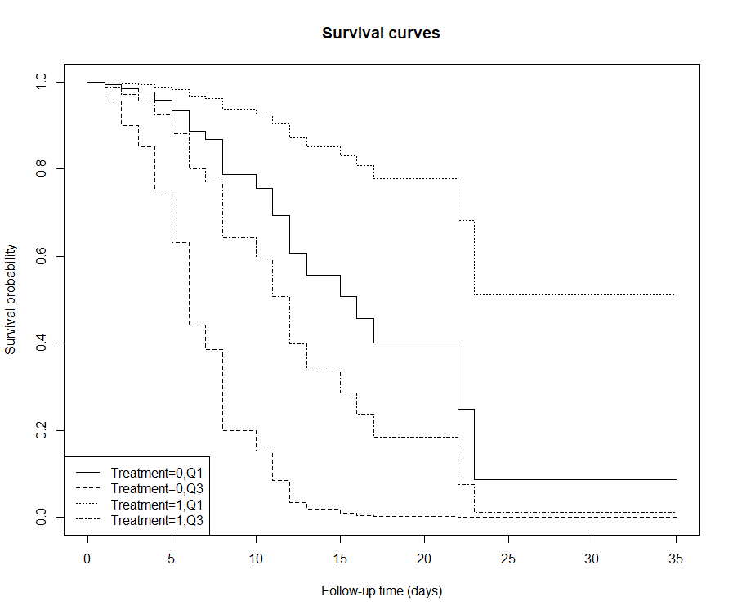

1. **Plot the estimated survival functions S(t|X1,X*2) at X1 ∈{0,1} and X*2 ∈{0,1} using Stratiﬁed Cox model (stratiﬁed by X*2). What is the HR of X1?**

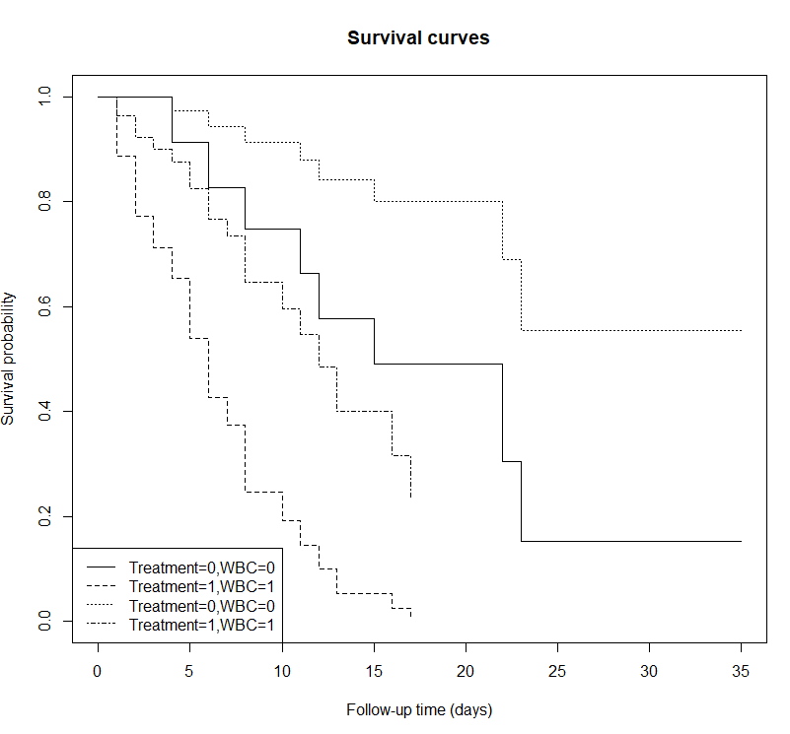

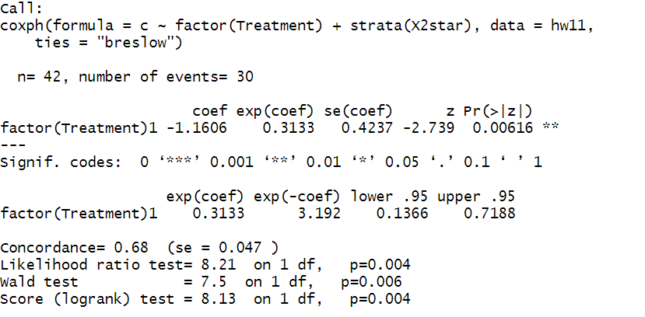

HR of X1(treatment):exp(-1.1606)=0.3133